6 sınıflar sorular
1.Aşağıdaki soruyu cevaplayınız?
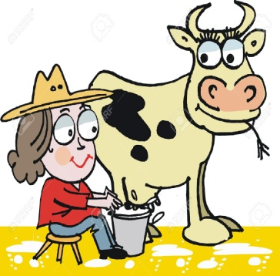
What is she doing?
a)She is drinking milk.
b)She is milking the cow.
c)She is feeding the cow.
d)She is taking the cow for a walk.

2. Sırasıyla hangi seçenekte verilmiştir?
a) upset / happy / sleepy
b) anxious / happy / upset
c) moody / sleepy / upset
d) upset / sleepy / happy

3- What's she doing now?
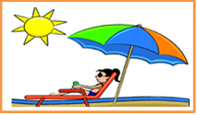
a) She is going on a sightseeing tour.
b) She is swimming in the pool.
c) She is sunbathing on the beach.
d) She is visiting an art gallery.

4. A: ..................do you go to the cinema?
B: Sometimes.
a) Where b) How often c) Who d) What time

5.Aşağıdaki boşluğa hangi seçenek gelmelidir.
Erzurum is…………………..than Adana.
a)younger b)colder c)taller d)hotter

6.Boşluğa uygun seçeneği yazınız.
I wear my ………………….. in sunny weather.
a)shorts b)gloves c)boots d)coat

7.A: ________is listening to music now?
B: Ahmet.
a)Who b) What c) Where d) Why

8.Tom doesn’t like hamburgers. He ….…… eats.
a) never b) always c) sometimes d)often

9. Eşleştirmelerden hangisi yanlıştır.
A) old X young b) fast X slow
c) good X fast d) hardworking X lazy

10.A:............do you go to the cinema?
B:Twice a month.
a)How often b) When c) Where d) What time

