**5 sınıflar**

**1.Cümlede boş bırakılan yere hangi kelime gelmelidir.**

She …………do her homework every Sunday.

a)didn’t b) don’t c)doesn’t d)aren’t

**2.Aşağıdaki boşluğa uygun kelime getiriniz.**

I like playing ………….

a)hunting b)Picture c)hopscotch d)tree

**3.Aşağıdaki cümlelerin hangisinde yanlışlık yapılmıştır?**

a)I brushes my teeth.

b) She walks every day).

c)They drink milk.

d)He visits zoo every weekend.

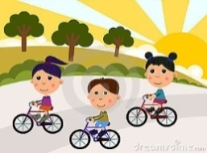**4- They like …………**

**A)** cycling **B)** jogging

**C)** hiking **D)** skating

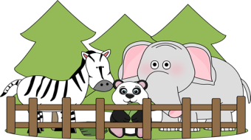

**5- A)** zoo **B)** park

**C)** cinema **D)** cafe

**6)Boş bırakılan yere hangi kelime gelmelidir?**

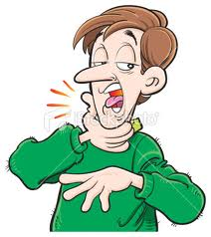

**‘I’ve got a sore throat. I shouldn’t ……….. ….’**

a) go to the doctor b) have a rest

c)drink cold water d)drink milk

**7)Cümledeki boşluğu tamamlayan doğru seçeneği işaretleyiniz.**

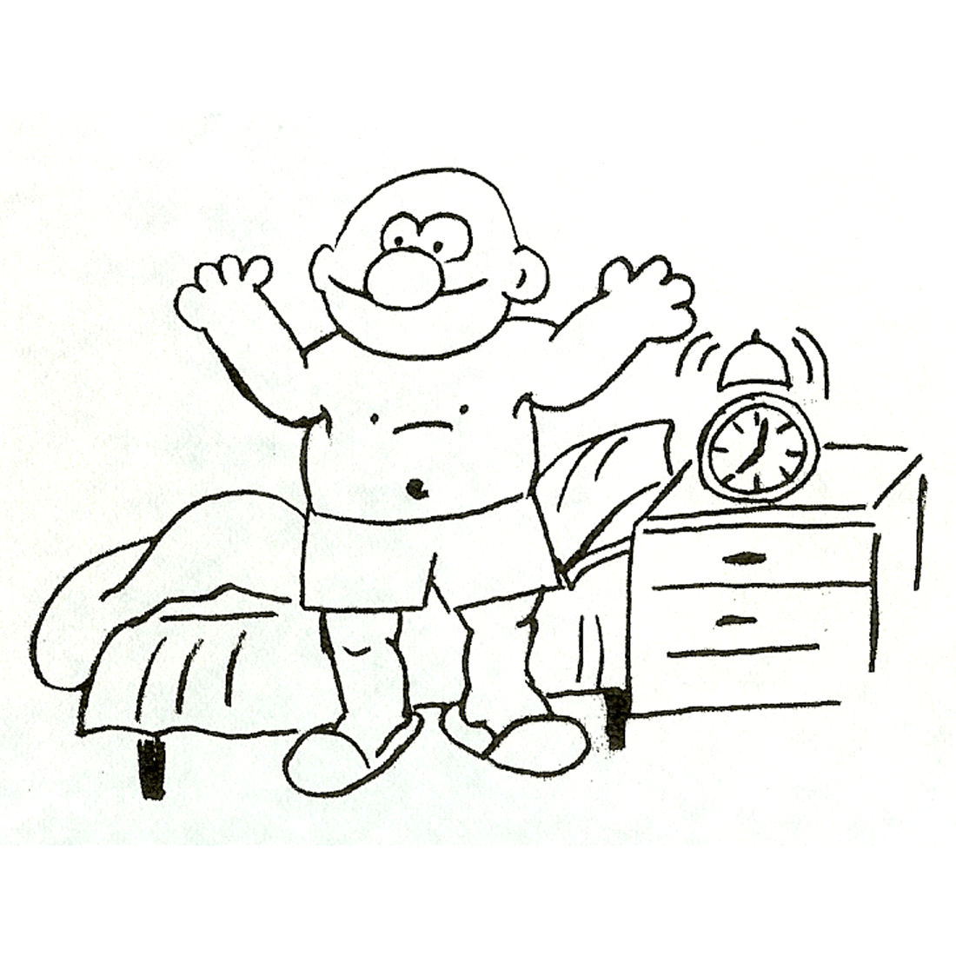

‘ I get up at 7 o’clock in the……………’

**a)breakfast b)morning**

**c)lunch d)afternoon**

**8)Aşağıdaki bilgilere göre hangisi yanlıştır?**

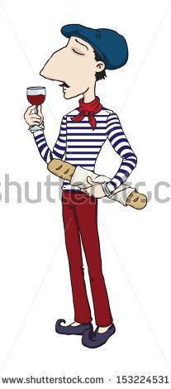

**Name: Alberto a)**He is from Italian.

**Age:28 b)**He is twenty-eight years old.

**Country: Italy c)**His name is Alberto.

**Language:Italian d)**He speaks Italian.

**9)Aşağıdakilerden hangisi resimdeki spordur?**

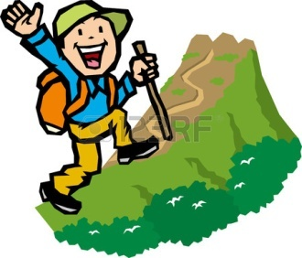

**a)Diving**

**b)Windsurfing**

**c)Trekking**

**d)Cycling**

10.They are from Spain . Their nationality is ………….

a- American b- Russian c- English d- Spanish